**Training Data Set Creation**

The training data set used for this analysis is shown below (first 5 lines):

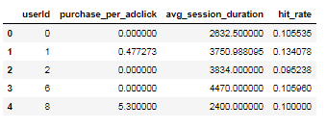

Dimensions of the training data set (rows x columns): **1193 x 3** (Not including the index column)

# of clusters created: **4**